**EVEREST ENGINEERING COLLEGE**

**(Affiliated to Pokhara University)**

**Sanepa-2, Lalitpur**



**[Subject Code: CMP 290]**

**A MINI PROJECT MID TERM REPORT ON**

**“EVEREST ENGINEERING COLLEGE”**

**Submitted By:**

**Prazwol Bishta [20070299]**

**Bibek Poudel [20070283]**

**Rikesh Lama Goley [20070306]**

**Hari Narayan Chaudhary [20070289]**

**Submitted To:**

**Department of Computer Engineering**

**September, 2022**

# ABSTRACT

Wordoku provides a simple interface for new version of the well-known sudoku game. In this variant you'll have to fill the square with a 9-letter word. You'll notice that it is a totally different experience from the original sudoku with numbers.

One of the benefits of playing Sudoku for brain health is to**promote thinking skill**. You can get this benefit while you practicing your logical thinking process when you are solving a puzzle. Indeed, playing Sudoku will train your brain and improve your thinking skill.

This game will find a spot in your favorites since it combines aspects of the all-time great game sudoku with letters.

**Key Words:** *Wordoku*

TABLE OF CONTENTS

ABSTRACT i

LIST OF FIGURES iii

LIST OF TABLES iv

CHAPTER 1: INTRODUCTION 1

1.1 Background 1

1.2 Problem Statement 1

1.3 Objectives 1

1.4 Project Features 1

1.5 Feasibility Analysis 2

1.5.1 Economic Feasibility 2

1.5.2 Technical Feasibility 2

1.5.3 Time Feasibility 2

1.5.4 Operational Feasibility 3

1.6 System Requirement 3

1.6.1 Software Requirement 3

1.6.2 Hardware Requirement 3

CHAPTER 2: LITERATURE REVIEW 4

CHAPTER 3: METHODOLOGY 5

3.1 Introduction 5

3.2 Hardware and software requirement 6

3.3 Proposed project block diagram 7

3.4 Entity-relationship model 8

3.5 Working principle 9

CHAPTER 4: WORK DONE AND REMAINING WORK 10

REFERENCES 11

CHAPTER 5: APPENDICES 12

# LIST OF FIGURES

**FIGURE PAGE**

Figure 3.1: Wordoku table--------------------------------------------------------- 5

Figure 3.2: Block Diagram of Worduko----------------------------------------- 7

Figure 3.3: Entity-Relationship Diagram----------------------------------------- 8

Figure 3.4: Flow Chart of Wordoku ---------------------------------------------- 9

Figure 4.1: Work Schedule--------------------------------------------------------- 10

Figure 5.1: Worduko initial console----------------------------------------------- 12

Figure 5.2: Selecting position to insert value-------------------------------------12

Figure 5.3: Inserting Invalid value-------------------------------------------------13

# LIST OF TABLES

**TABLE PAGE**

Table 4.1: Work Table-------------------------------------------------------------- 10

# INTRODUCTION

## Background

The history of Sudoku dates back to an 18th Century Swiss mathematician’s game called “Latin Squares” and some of the first number puzzles to appear in newspapers were published in France in 1895. a freelance puzzle inventor from Connersville, Indiana, USA in 1979 when it was published in *Dell Pencil Puzzles and Word Games* magazine. The puzzle was known as “Number Place,” since it involved placing individual numbers into empty spots on a 9 x 9 grid.The game first appeared in Japan in 1984 where it was given the name “Sudoku,” which means, “the digits are limited to one occurrence.”a number puzzle was much more successful in Japanese culture. Also, Japan tends to love puzzles, since it is a country where millions of people make lengthy commutes by train or bus, and they need to kill time while waiting for the next stop. Later in modern age it was upgraded in the alphabetical form and it is named as Wordoku.

## Problem Statement

* As most of us are in dilemma, how to kill boredom during free time ? Wordoku can be a best option.
* Few decade ago, it was playable in only newspapers which comes every week but now computer can generate unlimited wordoku table. 😊

## Objectives

* The main objective is to provide one of the existing methods for creating sudoku game (ALPHABETICAL) to play virtually.

## Project Features

* Provides the every letter must appear exactly once in each row, column, and 9x9 block.
* Some of the features of the proposed in wordoku game are:

1. Throw Invalid :
2. If user give random unspecified value.
3. Characters cannot be repeated in single row and column.
4. Easily playable :
5. Portable in nature.
6. Generate unlimited table for wordoku.
7. View details :
8. Table Details :- Hints are shown in such a way that puzzle can be solved successfully.
9. Exit System : Close the application.

## Feasibility Analysis

In the following way our project is feasible:

### Economic Feasibility

As Wordoku is a mini project done by 4 group members there is minimum cost assumed to be required as it is done based on our ideas and online resources.

### Technical Feasibility

This software is compatible for every computer with windows 7(and higher) as it is built using C language.

### Time Feasibility

The expected time for the completion of the project will be 2 to 3 weeks now.

### Operational Feasibility

Wordoku is easy to operate and have effective response to the user. This Software based program does not require any expert to handle as this is simple and can be played by anyone. The insertion and response time in the console application is fast.

## System Requirement

### Software Requirement

* MinGW compiler
* Any IDE(Integrated Development Tool) like codeblocks,Dev c/c++ etc.

### Hardware Requirement

* General PC with 1GB RAM(Minimum),100 GB ROM(Minimum)
* Processor i3 and higher
* VDU(13-inch to 15-inch wide-screen with a 1280 × 800 or 1366 × 768 resolution)

# LITERATURE REVIEW

The first project we reviewed was of Tarun Kumar from “Ims Engineering College, Gaziabaad” where he performed sudoku project in java swing. He had posted the project in March 16, 2015 where he has clearly explained his project regarding following topic. He used Java swing and code blocks to create the project. This project included features like scope of project, Solving methods etc. The user interface was simple and easy to use[1].

We also reviewed another project done by Gokul das at Oct 15, 2005. In this Project he created soduko game using C#. The Application starts with a nice looking splash form which leads to a Matrix sudoku table. Its was consists that rules of sudoku, Good Graphical presentation, Auto check the inserted value is correct or not, Auto generation of sudoku table etc [2].

On the basis of our study and research related to Wordoku game, many of the projects related to sudoku are Wordoku only. Many of the projects that we reviewed contained features like Generating automatic sudoku table, auto check the correct value, good graphics etc. They used their own header file externally. So, we decided to combine this feature in our game Wordoku. As we know making of Worduko game with the reference of sudoku is crucial thing. With these features everyone can play this game with different variant like number as well as alphabetical so they won’t get bored easily. This game is paperless and it reduces the limitation different sudoku table which required time.

# METHODOLOGY

## Introduction

We have used Dev-C++ IDE for development. [Dev-C++](http://dev-cpp.com/) is a full-featured C and C++ Integrated Development Environment (IDE) for Windows platforms. Millions of developers, students and researchers use Dev-C++ since the first version was released in 1998. It has been featured in dozens of C++ and scientific books and remains one of the favorite learning tool among universities & schools worldwide.

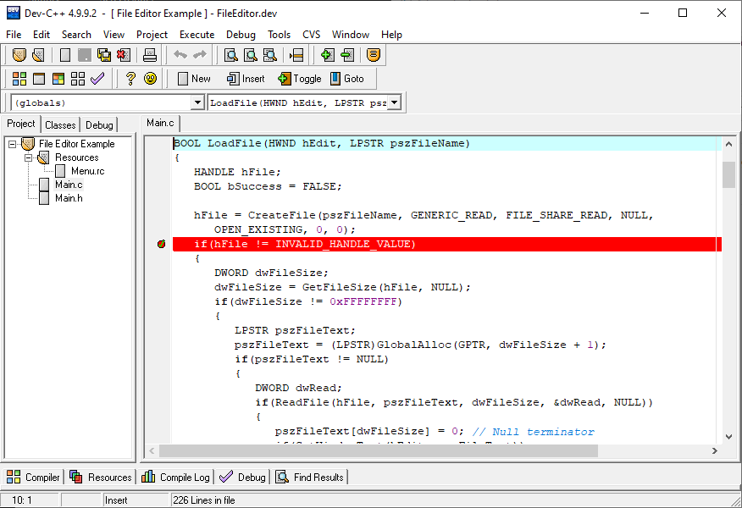

Fig 3.1 : Dev-C++

## Hardware and software requirement

* **Language- C:**

C is a general-purpose, procedure-oriented programming language pronounced as “C programming”. C is among the languages for Common Language Infrastructure. C is easy for users who have basic knowledge in programming.

* **IDE (Integrated Development Environment)-Dev-C++:**

Dev-C++ is an **IDE** developed by Bloodshed Software (Colin Laplace) until 2005, to make Operating system, console application, Web applications, web apps, mobile apps, cloud, and web services, etc. It is a language-specific we can use this to write code in C, C++ languages.

3.2 Proposed project block diagram

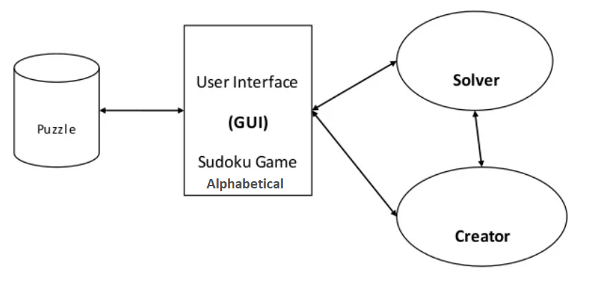

Fig 3.2: Block diagram of Proposed System

## Entity-relationship model

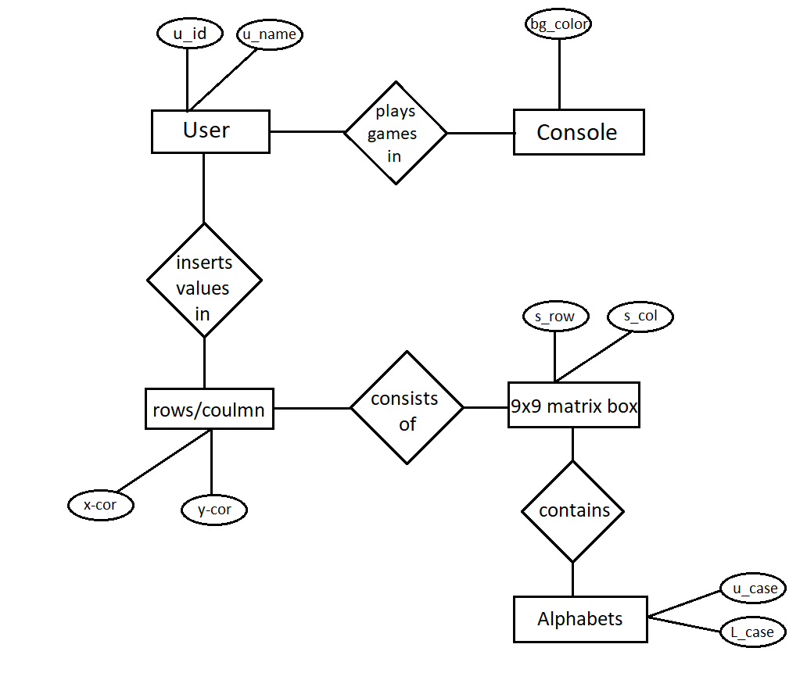

Fig 3.3: Entity-relationship diagram

## Working principle

## 

Fig 3.4: Flowchart of Proposed Wordoku

The application starts with a nice looking console form which leads to a Wordoku table. After the table presented user have to put valid value inside the table according to the rule, after finishing the puzzle its complete then they can exit the application.

# WORK DONE AND REMAINING WORK

|  |  |
| --- | --- |
|  | WORKS |
| Work Done | Matrix Wordoku Table, View Details, Insert Value, Check Availability in row and column. |
| Remaining Work | Make matrix wordoku table well organized, Check Availability with grid and repeat this process. |
| Table 4.1: Work Table  The working schedule be describe as:  We have scheduled our project to compete it within 3 weeks. Almost half of our project is completed only little portion of logic and well-organized table is remained to complete it. Till now we haven’t faced any big problem in our program. Work is expected to be completed within the end of October. | |

# REFERENCES

1. Hung, H., 2022. *Complete Sudoku Game for Windows using VB.NET 2013*. [online] Codeproject.com. Available at: <https://www.codeproject.com/Articles/832156/Complete-Sudoku-Game-for-Windows-using-VB-NET-2013> [Accessed 22 September 2022].
2. Bloodshed.net. 2022. *Home - Dev-C++ Official Website*. [online] Available at: <http://www.bloodshed.net/> [Accessed 22 September 2022].
3. [Programiz].Retrieved from https://www.programiz.com.(9/2/2021 7:00 AM)
4. Bloodshed.net. 2022. *Home - Dev-C++ Official Website*. [online] Available at: <http://www.bloodshed.net/> [Accessed 22 September 2022].
5. Bloodshed.net. 2022. *Home - Dev-C++ Official Website*. [online] Available at: <http://www.bloodshed.net/> [Accessed 22 September 2022].

# APPENDICES

We have the output of WORDOKU as shown below. Including its table.

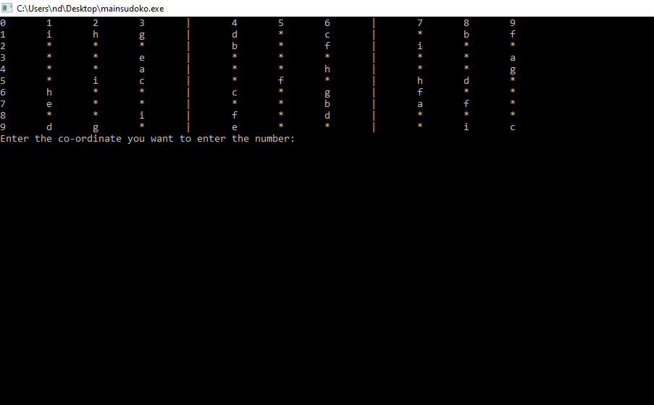

Fig 5.1: Wordoku initial console

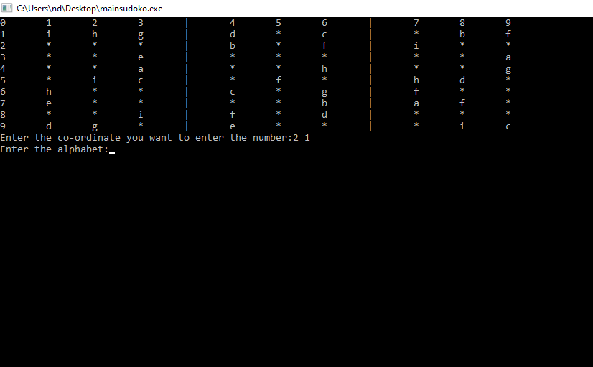

Fig 5.2: selecting position to insert value

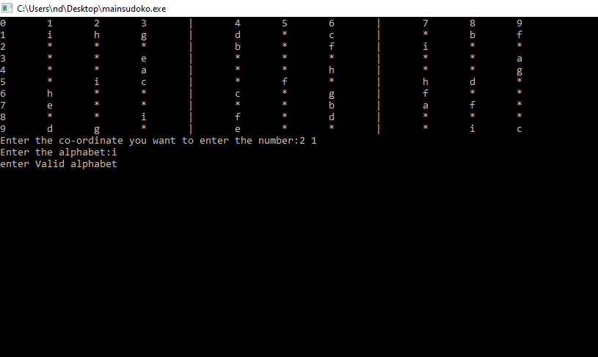

Fig 5.3: inserting invalid value